Practical 9: -In-Memory Caching and Query Optimization
Objective: | To implement server-side caching and measure its impact on API response time.
Problem Statement: | • Add in-memory caching to the Task Management backend using node- cache.  • Cache the response of GET /tasks (all tasks) with a reasonable TTL (e.g., 60 seconds).  • Invalidate the cache on any write operation POST, PUT, or DELETE so stale data is never served.  • Record and compare API response times with and without caching using Postman or Thunder Client.  • Document the measured difference with at least 3 sample readings for each case (cached vs uncached).
Implementation | Cache Code:  import NodeCache from 'node-cache';  /**  * In-Memory Cache Service using node-cache  *  * Configuration:  * - stdTTL: 60 seconds (standard expiration window)  * - checkperiod: 120 seconds (background expired-key garbage collection)  */  const nodeCache = new NodeCache({ stdTTL: 60, checkperiod: 120 });  // Telemetry counters for cache performance tracking (Supplementary Problem 2)  const counters = {  hits: 0,  misses: 0,  sets: 0,  invalidations: 0,  };  export const cache = {  /**  * Retrieves an item from cache. Tracks hits/misses.  * @param {string} key  * @returns {any|null}  */  get: (key) => {  const value = nodeCache.get(key);  if (value !== undefined) {  counters.hits += 1;  return value;  }  counters.misses += 1;  return null;  },  /**  * Stores an item into cache with standard or custom TTL.  * @param {string} key  * @param {any} val  * @param {number} [ttl]  * @returns {boolean}  */  set: (key, val, ttl) => {  counters.sets += 1;  if (ttl !== undefined) {  return nodeCache.set(key, val, ttl);  }  return nodeCache.set(key, val);  },  /**  * Invalidates a specific key from cache.  * @param {string|string[]} key  * @returns {number}  */  del: (key) => {  counters.invalidations += 1;  return nodeCache.del(key);  },  /**  * Invalidates all keys starting with a given prefix.  * @param {string} prefix  * @returns {number}  */  delPrefix: (prefix) => {  const keys = nodeCache.keys();  const matched = keys.filter((k) => k.startsWith(prefix));  if (matched.length > 0) {  counters.invalidations += matched.length;  return nodeCache.del(matched);  }  return 0;  },  /**  * Clears the entire cache.  */  flush: () => {  counters.invalidations += nodeCache.keys().length;  return nodeCache.flushAll();  },  /**  * Returns telemetry metrics (hit/miss counts, ratios, active keys).  * Used by the debug endpoint.  */  getMetrics: () => {  const total = counters.hits + counters.misses;  const hitRatio = total > 0 ? `${((counters.hits / total) * 100).toFixed(2)}%` : '0.00%';  const keys = nodeCache.keys();  return {  hits: counters.hits,  misses: counters.misses,  sets: counters.sets,  invalidations: counters.invalidations,  hitRatio,  totalRequests: total,  activeKeysCount: keys.length,  keys,  stdTTL: 60,  };  },  /**  * Direct access to underlying NodeCache instance.  */  raw: nodeCache,  };  export default cache;  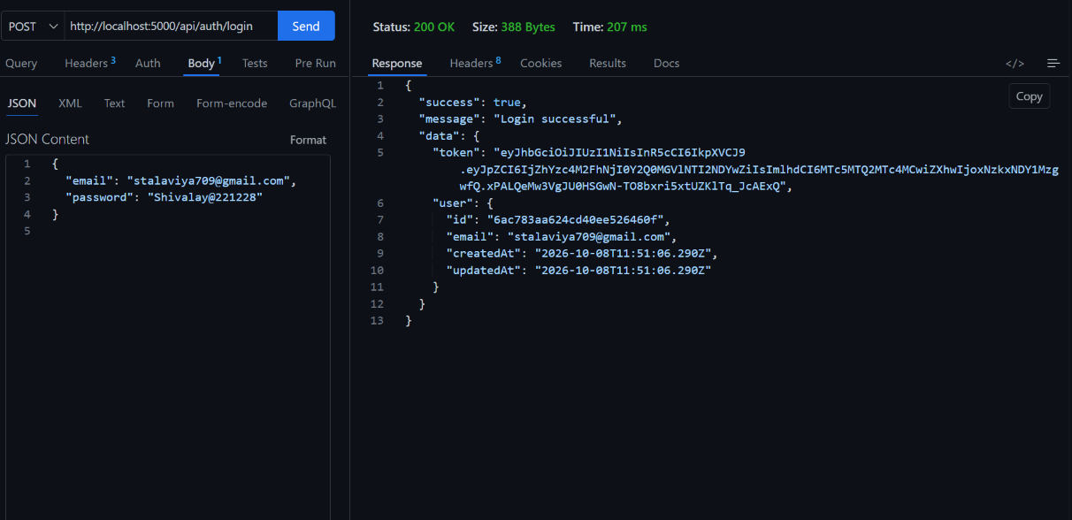  From the Cache:-  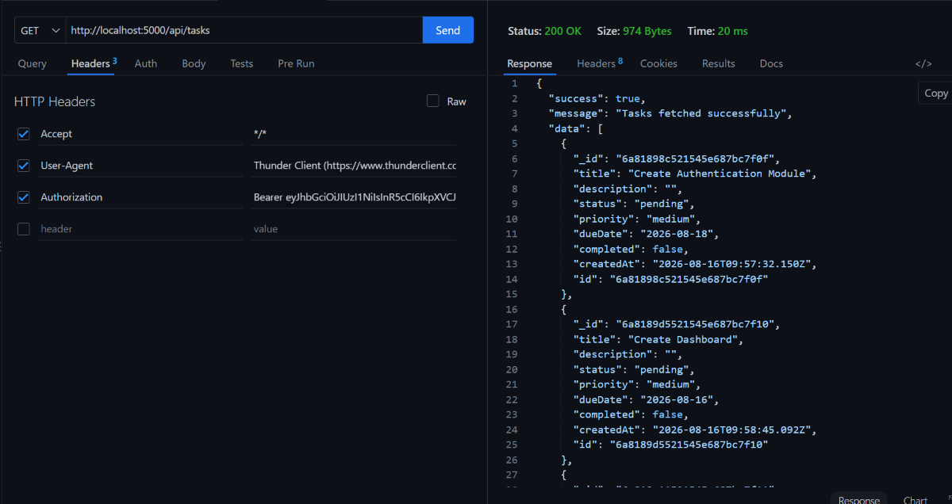
Outcome | Students will be able to implement in-memory caching for a REST API, ensure cache correctness through invalidation, and measure the performance impact using real response time data.

